Pass for level 22: chG9fbe1Tq2eWVMgjYYD1MsfIvN461kJ

Step 1:Login to natas 21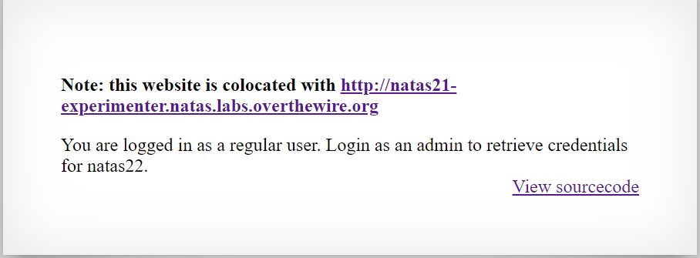

Step 2:View source code

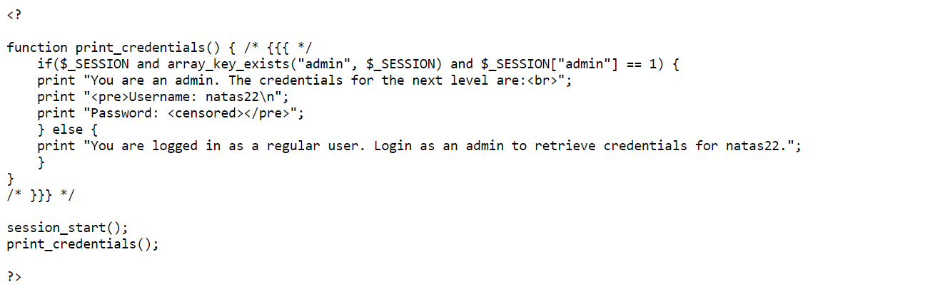

It is not clear what we need to do for "admin 1" in session.

Step 3: connect to the second website

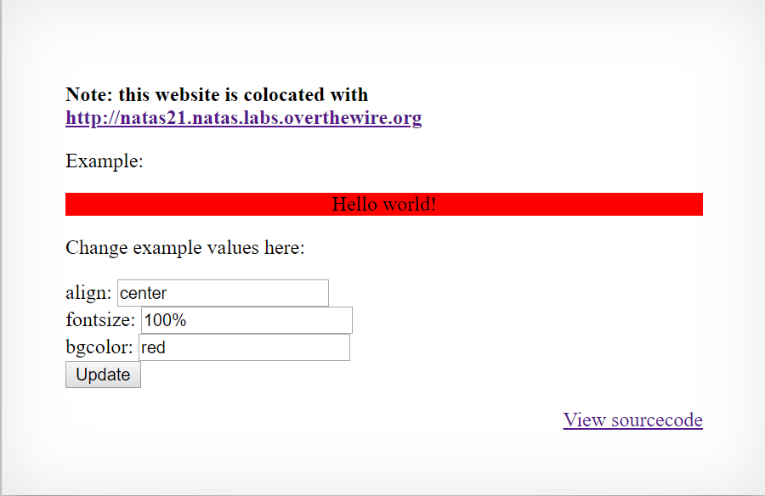

Step 4:View source code

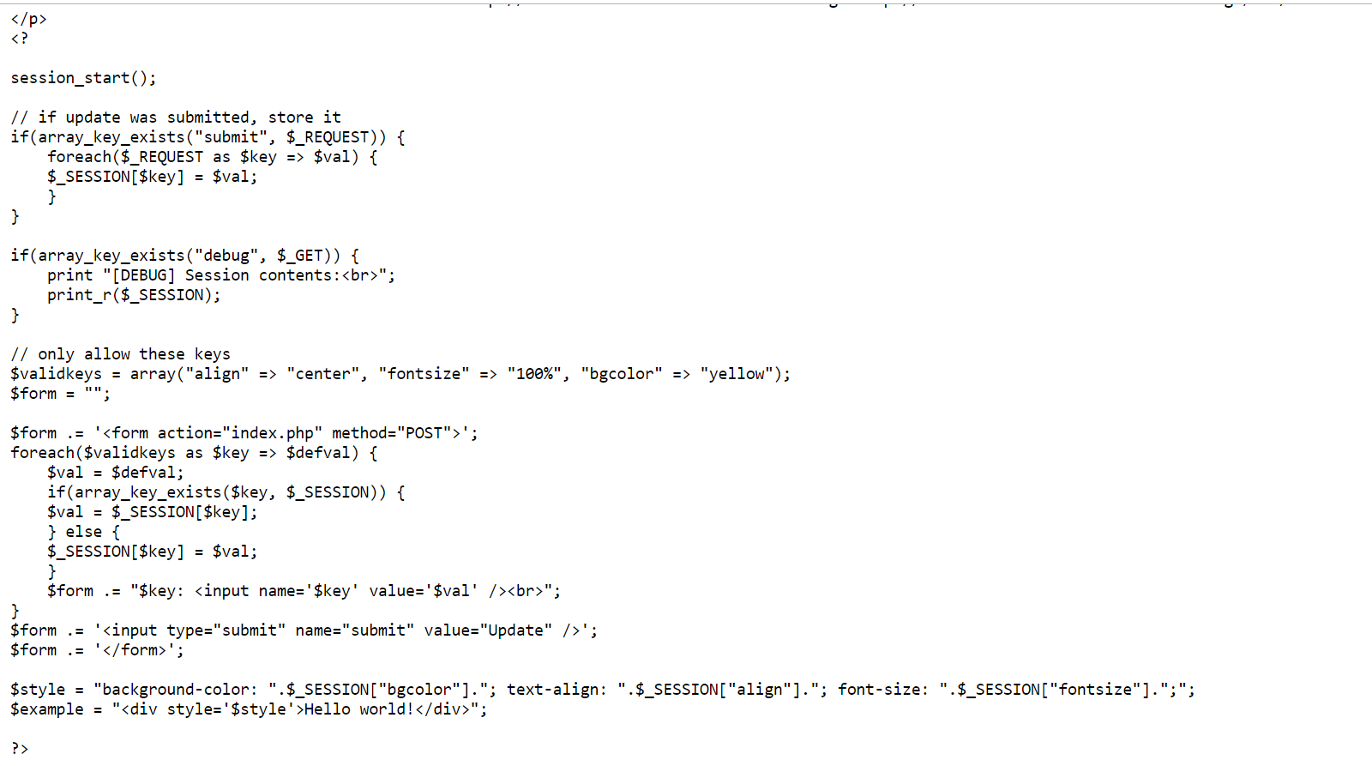

We can see in the first function that if we will post 'submit' : '1' to the web server then the function will loop over the requests we will post and store them as key and value.

With ?debug=true help we can see the array of keys and values.

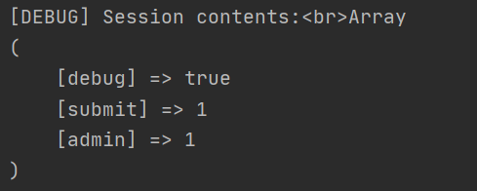

Step 5: When we posted admin 1 we can use the 'PHPSESSID' cookie value to post it to the original website and see if we got access.

